Predictive Modelling for Bank Marketing Campaign Analysis

University of Hertfordshire
Student ID – 25000363
Module – Data Science Laboratory 1/ Coursework 3
Academic Year – 2025/26

Contents
1.Introduction 1
2.Data Preprocessing and Methodology 1
Dataset Overview 1
Data Preprocessing 1
3.Exploratory Data Analysis 1
Target Variable Distribution 1
Age Distribution of Customers 2
4. Model Selection and Hyperparameters 2
5.Model Performance 2
Confusion Matrix Analysis 3
Feature Importance Analysis 4
ROC Curve and AUC Analysis 4
6.Interpretation and Discussion 5
Model Interpretability 5
Model Limitations and Challenges 5
Recommendations for Improvements 5
7.Git Workflow and Version Control 5
8.Conclusion 5
9.References 6

1.Introduction
The purpose of this document is to analyze data from bank marketing campaigns using a Decision Tree classification model. The focus of this report is to analyze data from bank marketing campaigns to forecast if a client will enroll in a term deposit, depending on several demographic and campaign-related factors. The data contains records of bank clients who were contacted in the course of bank marketing campaigns, along with records of their personal and financial characteristics. The campaign data also contains records of the clients’ interactions with the campaign.

2.Data Preprocessing and Methodology

Dataset Overview
The bank marketing dataset has 11,162 customers with 17 features including demographic information (age, job, education), financial information (balance, loans) and campaign information (contact duration, contacts). The target variable represents the client’s subscription for a term deposit. The goal here is to develop a predictive model that enables the prediction of the likelihood of customers subscribing and the most important features that contribute to the conversion.

Data Preprocessing
Some of the categorical variables had the values ‘unknown’. These values were handled using the label encoding technique. All the categorical variables were transformed using the Label Encoding technique. This technique converts the text values into numerical values. The target variable was encoded into binary values (0 = no, 1 = yes). This encoding strategy was chosen because decision trees can naturally handle categorical variables through their splitting criteria and label encoding preserves the discrete nature of categories without introducing artificial ordinality assumptions that would be problematic with other algorithms.

3.Exploratory Data Analysis
Exploratory data visualization was used to understand the structure, distribution and relationships within the dataset before modelling. It helped identify class imbalance, feature patterns and potential limitations, ensuring that the selected model was appropriate and the results were interpreted correctly.

Target Variable Distribution
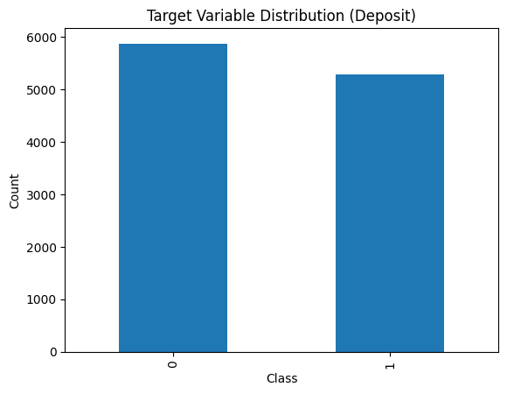
Figure 1: Target variable Distribution (Deposit)
The bar chart presented above displays the count of customers that subscribed and did not subscribe to the term deposit. This figure 1 exhibits a mild class imbalance, whereby non-subscribers occur more frequently than subscribers. This is relevant because it might have implication on the model metrics and performance.

Age Distribution of Customers
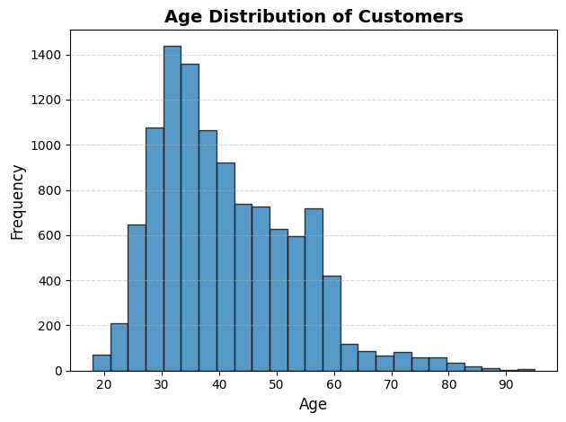
Figure 2: Age Distribution of Customers
The histogram illustrates the spread of customer ages for the dataset. The majority of customers are middle aged, which shows the campaign targeted mainly working age customers.

4. Model Selection and Hyperparameters
A Decision Tree classifier has been chosen for this classification problem due to its interpretability, ability to handle non-linear data and robustness to outliers. The following parameters have been chosen to avoid overfitting and improve the model’s ability to generalize the maximum depth of the tree has been set to 6 levels, the minimum samples required to split has been set to 30, the minimum samples required to be at a leaf node has been set to 15, the Gini impurity criterion has been used to determine the best split and a random state of 42 has been used to ensure reproducibility. An 80-20 stratified split has been used to divide the data into training and test sets.

5.Model Performance
The Decision Tree model achieved the following performance in the test set:
Class | precision | recall | f1-score
0 | 0.83 | 0.80 | 0.82
1 | 0.79 | 0.82 | 0.80
Table 1: Model Performance
- Accuracy: 0.8101209135691895
The accuracy of the Decision Tree model was found to be 81% for the test set. The precision of the non-subscriber class was 0.83 and the recall was 0.80. For the subscriber class the precision was 0.79 and the recall was 0.82. It can be observed that there are minor variations between the two classes. Moreover, the fact that the macro and weighted averages are the same (0.81), shows that there is no bias towards either of the classes and the results are reliable.

Confusion Matrix Analysis
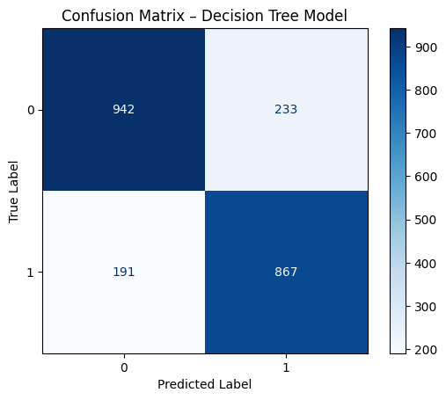
Figure 3: Confusion Matrix
As shown in the confusion matrix the Decision Tree model was able to classify 942 non-subscribers and 867 subscribers correctly. Although the model was able to classify 233 non-subscribers as subscribers and 191 subscribers as non-subscribers, the number of correct classifications is greater than the number of incorrect classifications. This suggests that the model performs reliably with balanced classification performance across both classes.

Feature Importance Analysis
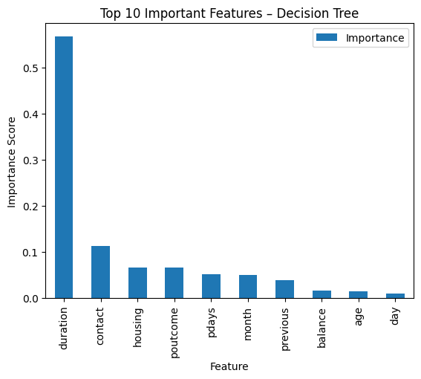
Figure 4: Top 10 Importance Features
From the results obtained in the feature importance analysis it is clear that the duration of the call is the most important factor in determining the prediction results regarding the subscription of deposits. Other factors such as the type of contact, the housing loan and the results of the previous campaigns also influence the decisions made by the model, although not to such a great extent. The features such as the age and balance have relatively low importance values.

ROC Curve and AUC Analysis
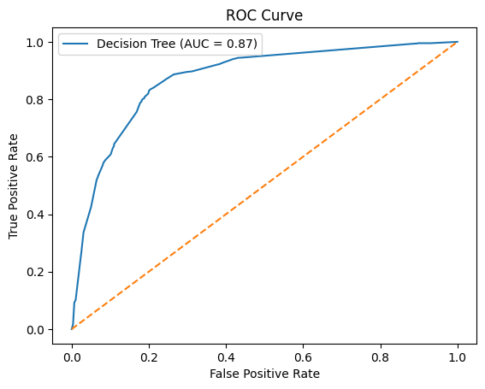
Figure 5: ROC Curve
The ROC curve shows the performance of the model in discriminating between deposit subscribers and non-subscribers at different classification thresholds. The AUC score of 0.87 shows good discriminatory performance. Therefore, the model can differentiate between the classes of deposit subscribers and non-subscribers.

6.Interpretation and Discussion

Model Interpretability
One of the main advantages of the Decision Tree algorithm is that it is naturally interpretable. The tree can be visualized and understood in terms of if-then rules, which makes the prediction easy to understand. Every branch in the tree represents a decision based on thresholds in features. The path from the root to the leaf node shows the reasoning behind each prediction. This is especially important in banking scenarios, where decisions have to be justified.

Model Limitations and Challenges
However, it is important to note that while it is quite easy to interpret this Decision Tree model, it has some limitations. The major limitation is that it is dealing with class imbalanced data as deposit subscriptions make up a small percentage of the total data. As a result, it is more likely to predict the majority class, which is “no subscription”. Moreover, it is likely to be suffering from overfitting.

Recommendations for Improvements
The limitation of the model can be overcome by using several modifications. Class imbalance can be overcome by using methods such as SMOTE and class weights. Ensemble methods such as Random Forest and Gradient Boosting can be used to overcome the limitation of the model and to improve the performance of the model. Cost sensitive learning can be used to overcome the limitation of the model by reducing the bias of the majority class.

7.Git Workflow and Version Control
This project employed Git version control system to organize the code and monitor the development process. Branches were created to handle preprocessing, modelling and visualization with important commits indicating the major milestones in the project. The commit history offers transparency and proper documentation of the project including the entire process and the proper stages involved.

8.Conclusion
In this coursework, a Decision Tree model has been used to predict the subscriptions of the bank’s term deposit product and the entire machine learning process has been covered. Though the model has shown promising results in terms of accuracy, the problem of class imbalance has affected the efficiency of the model. Feature importance has shown some of the important variables including contact duration and balance to be important in the model. Evaluation has also been done using different metrics to obtain a deeper insight into the model’s efficiency.

9.References
1.Kaggle. Bank Marketing Dataset. Retrieved from https://www.kaggle.com/datasets/janiobachmann/bank-marketing-dataset
2.Scikit-learn Development Team. (2024). Scikit-learn: Machine Learning in Python. Available at: https://scikit-learn.org
3. Fawcett, T. (2006). An introduction to ROC analysis. Pattern Recognition Letters, 27(8), 861-874. https://doi.org/10.1016/j.patrec.2005.10.010
4. Pedregosa, F., et al. (2011). Scikit-learn: Machine learning in Python. Journal of Machine Learning Research, 12, 2825-2830.

